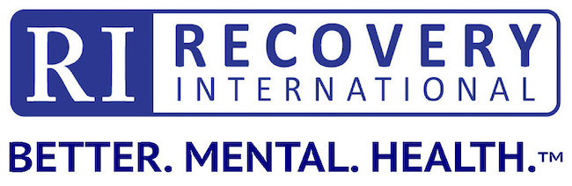

Complaint Status Form

In most instances, complaints can effectively be resolved through conversations between the parties involved, Area Leaders, or RI staff. In instances when that is not sufficient, members of Recovery International Inc. may use this form to formally express complaints and concerns. The Complaint Status Report will be used as a tool to document complaints regarding meetings and satisfaction with service.

If you have already talked with your Group Leader, Area Leader and program staff and still wish to file a formal complaint, please complete this form and send it to Sandra Wilcoxon, CEO, via e-mail: swilcoxon@recoveryinternational.org. You will be contacted within a week of submission.

Your name: ______________________________________Date:__________________

e-mail:______________________________ Phone:___________________________

Focus of Complaint:

____ Meeting ____ Program ___ Service ___ Other:_____________________

Description of Incident/Complaint: (please include meeting location and/or people involved)

Who did you first talk to regarding this? _____________________________________________

What was their response?_________________________________________________________

What would you like to see done to address your concerns?_____________________________

- - - - - - - (office use only)

Date Received:_________________

___ Forwarded to Compliance Officer

___ Follow-up call or e-mail with Complainant

Notes:______________________________________________________________________

____ Resolved ___ Not Resolved

- - - - -

____ Forwarded to Board President

Notes:______________________________________________________________________

____ Resolved ___ Not Resolved

